Screenshot of the working program:

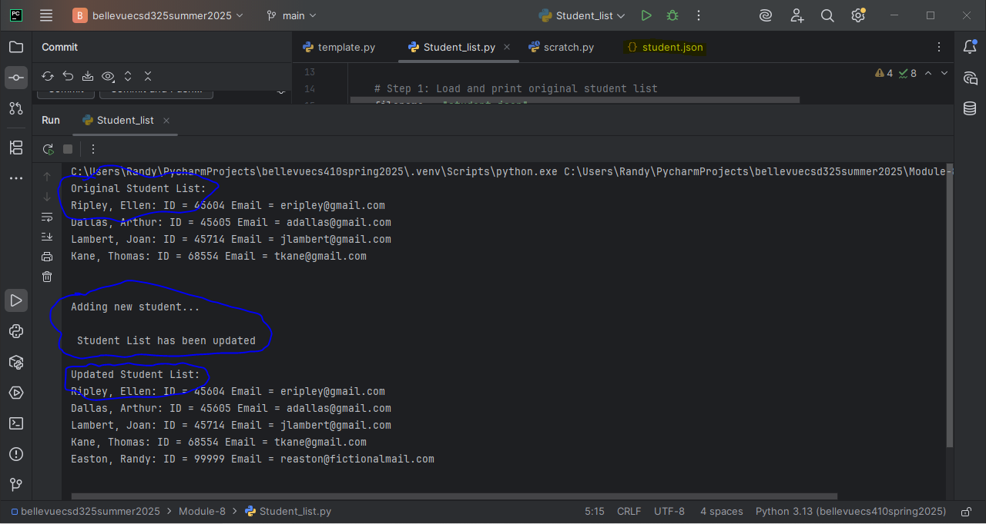

Take note of the highlighted student.json

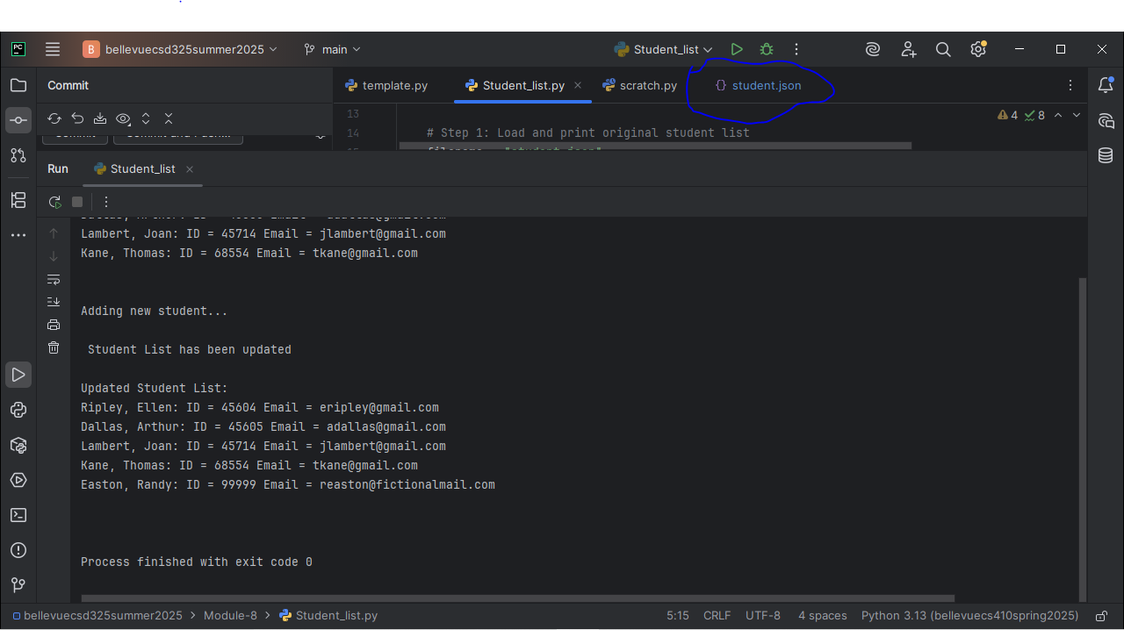

My IDE doesn’t provide notifications that the file I’m working with has changed unless a completely different program edits it. Instead, if a change happens, it highlights the file and tab in blue as shown in the screenshot.

Also, it doesn’t prompt me to save. In the program, I provided a method to save the JSON file beforehand, etc.